**Web Programming – CS4032**

**Assignment 01**

**Name: Razeen Shahid**

**Roll Number: 21F-9224**

**Section: BSCS-6B**

**Course Instructor: Muhammad Hannan Farooq**

TASK 01:

Code:

<!DOCTYPE html>

<html>

<head>

<title>Razeen Shahid's Webpage</title>

</head>

<body>

<h1>Hello! My name is Razeen Shahid</h1>

<br>

<h2>Roll Number: 21F-9224</h2>

<h2>Section: BSCS-6B</h2>

<br>

<h3>About Me</h3>

<p>A highly motivated Computer Science student capable of meeting tight deadlines, seeking a challenging data analyst position. I have experience in programming, statistical analysis, and data visualization to provide valuable business insights.</p>

</body>

</html>

OUTPUTS:

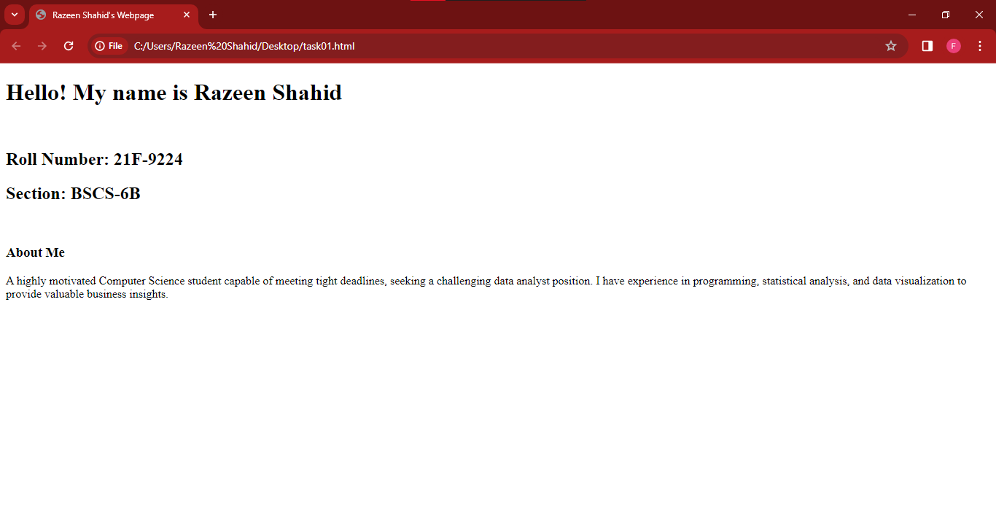

TASK 02:

Code:

<!DOCTYPE html>

<html>

<head>

<title>Razeen Shahid's Webpage</title>

</head>

<body>

<p><b>This text is bold</b></p>

<br>

<p><strong>This text is strong</strong><p>

<br>

<p><big>This text is big</big></p>

<br>

<p><i>This text is italic</i></p>

<br>

<p><em>This text is italic</em></p>

<br>

<p>This is computer output</p>

<br>

<p><i>This is <sub>subscript<sub> and <sup>superscript</sup></p>

<br>

</body>

</html>

OUTPUTS:

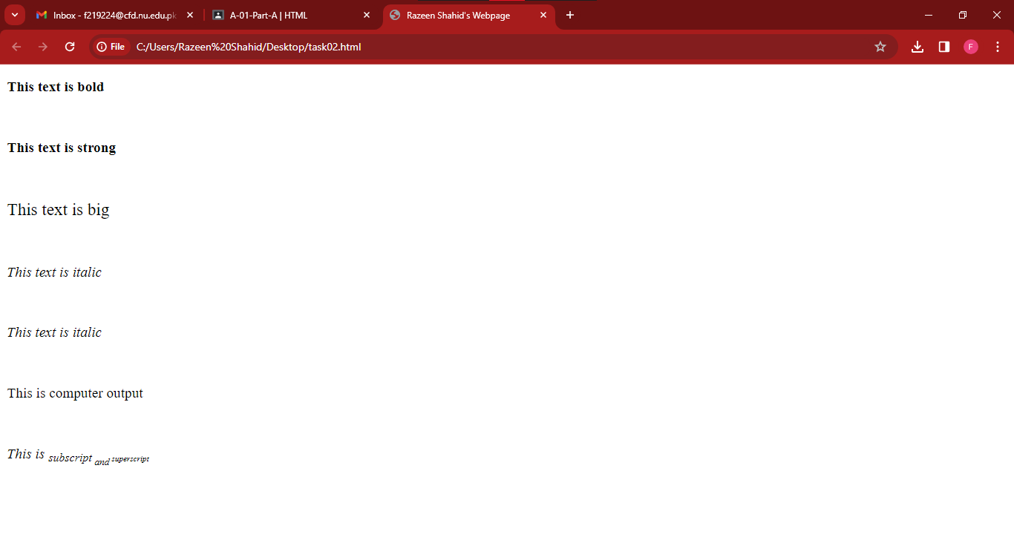

TASK 03:

Code:

<!DOCTYPE html>

<html>

<head>

<title>Razeen Shahid's Webpage</title>

</head>

<body>

<img src="logo1.png" alt="Fast NU" width="1000" height="1000">

</body>

</html>

OUTPUTS:

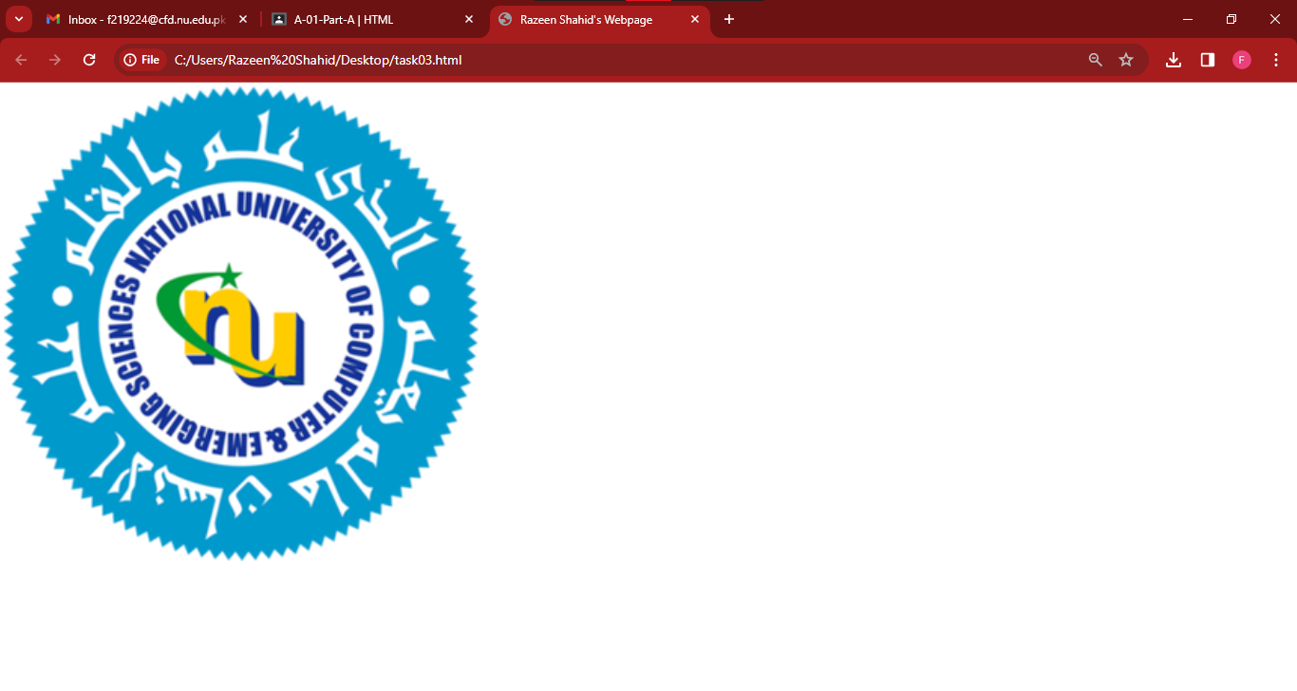

TASK 04:

Code:

<!DOCTYPE html>

<html>

<head>

<title>Razeen Shahid's Webpage</title>

</head>

<body>

<a href="https://www.nu.edu.pk/" target="_blank">

<img src="logo1.png" alt="Fast NU" width="1000" height="1000">

</a>

</body>

</html>

OUTPUTS:

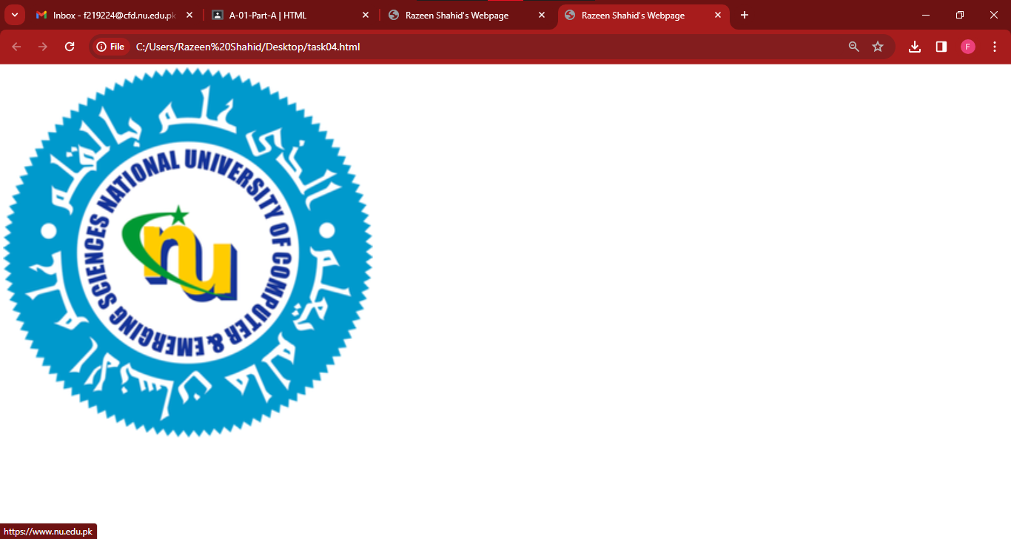

TASK 05:

Code:

<!DOCTYPE html>

<html>

<head>

<title>Razeen Shahid's Webpage</title>

</head>

<body>

<h2>HTML Lists</h2><br>

<h3> Unordered list </h3>

We have books on a variety of languages:

<ul>

<li>Oracle</li>

<li>Java</li>

<li>HTML</li>

<li>CSS</li>

</ul>

<h3> Ordered list </h3>

Follow these steps to install Java:

<ol>

<li>Download the software</li>

<li>Extract to a folder</li>

<li>Double click the executable to run</li>

</ol>

</body>

</html>

OUTPUTS:

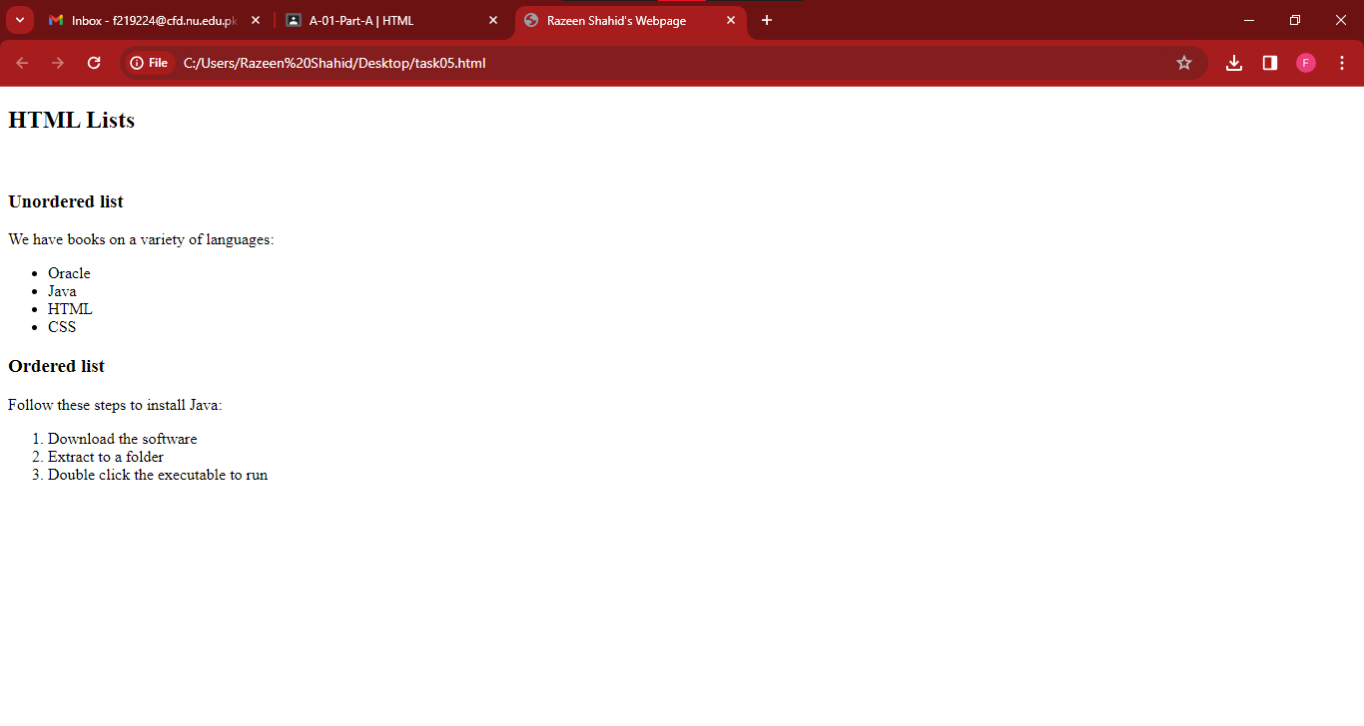

TASK 06:

Code:

<!DOCTYPE html>

<html>

<head>

<title>Razeen Shahid's Webpage</title>

</head>

<body>

<table border="1">

<tr>

<td rowspan="4">April</td>

<td>Empty</td>

<td>Empty</td>

</tr>

<tr>

<td>Empty</td>

<td>Empty</td>

</tr>

<tr>

<td>Empty</td>

<td>Empty</td>

</tr>

<tr>

<td>Empty</td>

<td>Empty</td>

</tr>

<tr>

<td>Empty</td>

<td>Empty</td>

<td>Empty</td>

</tr>

<tr>

<td>Empty</td>

<td>Empty</td>

<td>Empty</td>

</tr>

</table>

</body>

</html>

OUTPUTS:

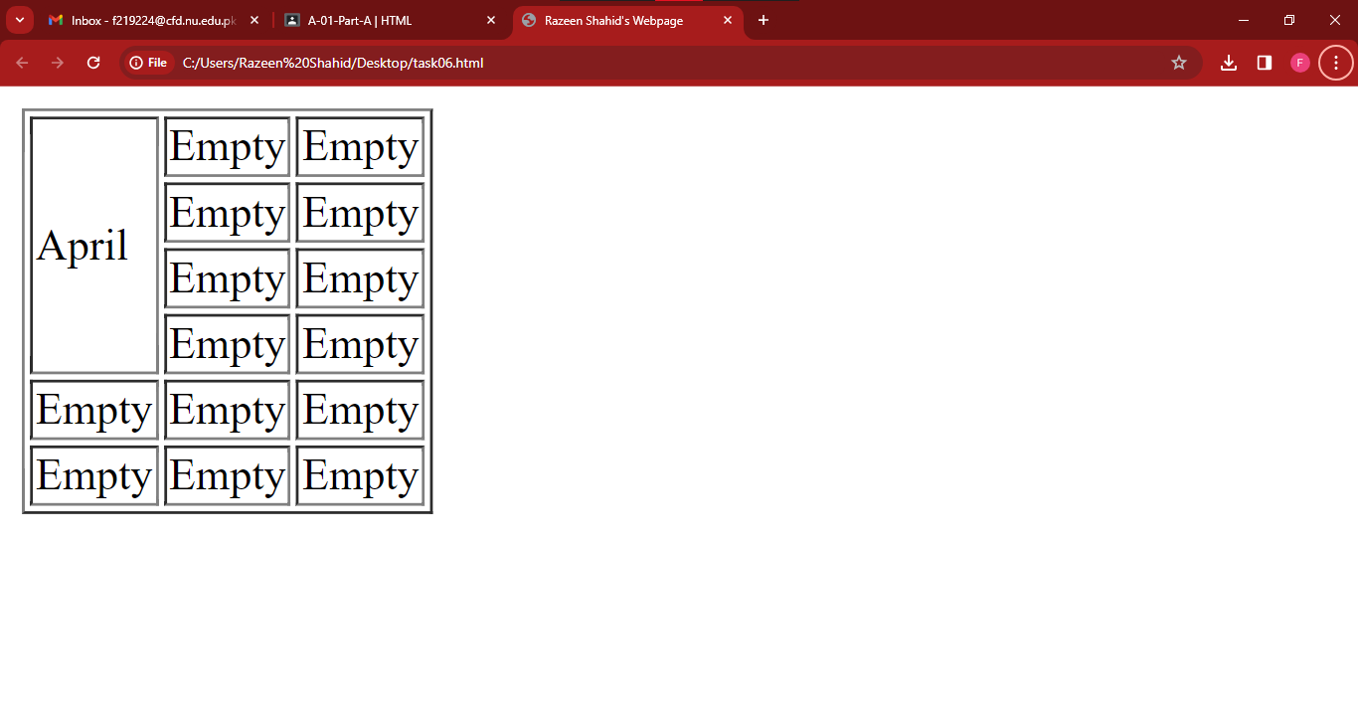

TASK 07:

Code:

<!DOCTYPE html>

<html>

<head>

<title>Razeen Shahid's Webpage</title>

</head>

<body>

<table border="1">

<tr>

<td colspan="3">2022</td>

</tr>

<tr>

<td>Empty</td>

<td>Empty</td>

<td>Empty</td>

</tr>

<tr>

<td rowspan="2" colspan="2">FIESTA</td>

<td>Empty</td>

</tr>

<tr>

<td>Empty</td>

</tr>

<tr>

<td>Empty</td>

<td>Empty</td>

<td>Empty</td>

</tr>

</table>

</body>

</html>

OUTPUTS:

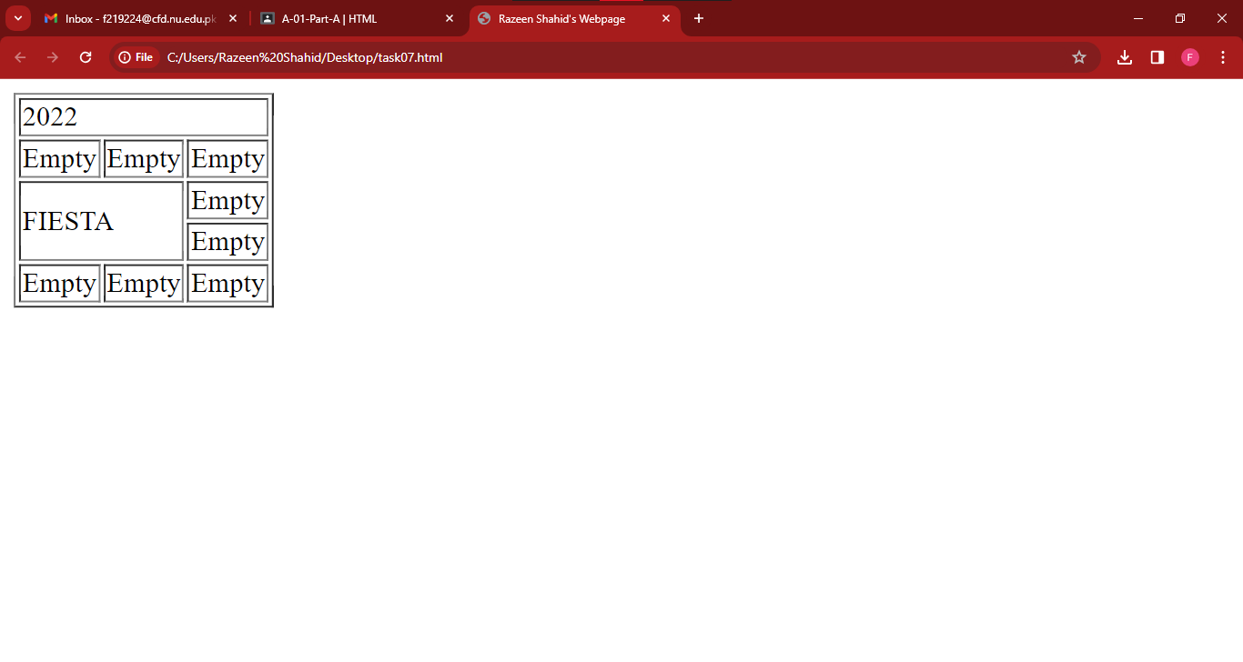

TASK 08:

Code:

<!DOCTYPE html>

<html>

<head>

<title>Razeen Shahid's Webpage</title>

</head>

<body>

<form>

<h2 >SignUp</h2>

<input type="text" id="username" placeholder="Eg. Razeen_30" required><br><br>

<input type="email" id="email" placeholder="email@example.com"><br><br>

<input type="password" id="pass" placeholder="Password" required><br><br>

<input type="password" id="pass" placeholder="Confirm Password" required><br><br>

<input type="submit" value="Submit"><br><br>

<input type="reset" value="Reset">

</form>

</body>

</html>

OUTPUTS:

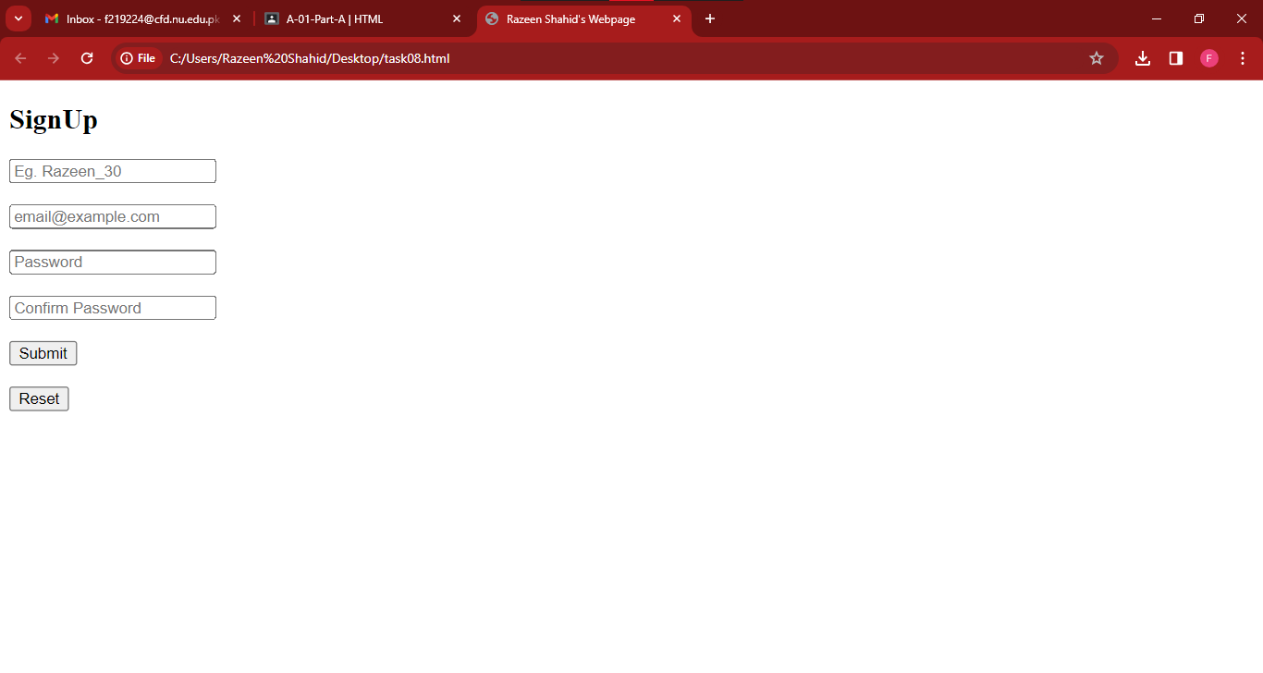

TASK 09:

Code:

<!DOCTYPE html>

<html>

<head>

<title>Pete's Pizza Delivery</title>

</head>

<body>

<center>

<h1><b>Pete's Pizza Delivery</b></h1>

<h3><b>Online Order Form </b></h3>

</center>

<center>

<form action="">

<table>

<tr>

<td>*Name:<input type="text" name="name" id="" required></td>

<td>*Tel:<input type="tel" name="tel" required></td>

</tr>

<tr>

<td>*Address:<input type="text" name="Address" id="" required></td>

<td>*Email:<input type="email" name="email" id="" required></td>

</tr>

<tr>

<td>*Town/city:<input type="text" name="towncity" id="" required></td>

</tr>

<tr>

<td>*Postcode:<input type="text" name="postcode" id="" required></td>

</tr>

</table>

<form action="">

<br><br>

<p><b>* required fields</b></p>

<table>

<tr>

<th>Topping</th>

<th>Size</th>

<th>Extras</th>

</tr>

<br>

<tr>

<td><input type="radio">Margherita</td>

<td><input type="radio">Small</td>

<td><input type="checkbox">Mushrooms</td>

</tr>

<tr>

<td><input type="radio">Four Seasons</td>

<td><input type="radio">Medium</td>

<td><input type="checkbox">Green peppers</td>

</tr>

<tr>

<td><input type="radio">Meat Feast</td>

<td><input type="radio">Large</td>

<td><input type="checkbox">Anchovies</td>

</tr>

<tr>

<td></td>

<td></td>

<td><input type="checkbox">Extra Cheese</td>

</tr>

</table>

<br><br><br>

Preffered delivery time: <input type="time" id="time" align="left">

<br>

Delivery instructions: <textarea rows="5" cols="30"></textarea>

<br>

<button>Submit Order</button>

</form>

</center>

</body>

</html>

OUTPUTS:

